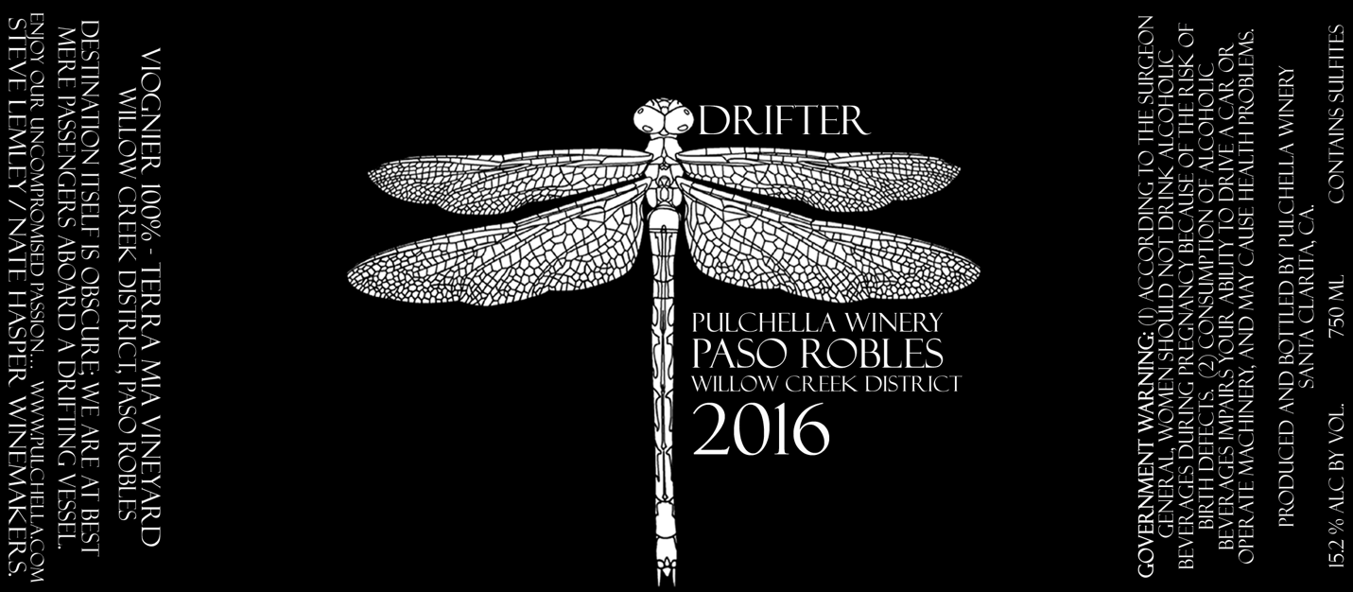
2016 Drifter

Winemakers Tasting Notes  This is the second vintage of our Viognier, Drifter. The nose is very fragrant and begins with an explosion of tropical fruits: guava, passion fruit, apricots and fresh white peaches that mingle with honeysuckle and subtle notes of wild flowers.  Crisp and fresh on the front of the palate, the wine offers a great balance of tropical fruit notes – pineapple, passion fruit, cantaloupe, lemon zest – and a crisp mineral-driven finish with a wonderful dash of acidity. Extremely refreshing and just begging to be drank! 75 cases produced – Drink Now!  Vineyard Notes:  Terra Mia is located just minutes from downtown Paso Robles yet postured in the center of the historic Templeton Gap. The vineyard is nestled onto 30 acres in the Willow Creek District of the Paso Robles AVA.  Suggested Food Pairings:  This wine goes surprisingly well with a wide variety of Asian inspired dishes and flavors, seafood and is a great choice for aged hard cheeses.  Let’s not forget about enjoying this bay boy by itself on a hot summer day by the pool or on the patio! | Appellation Willow Creek District, Paso Robles Brix At Harvest 27.1  Varietal 100% Viognier PH 3.47  Vineyard Terra Mia Acidity .745  Release Date 3/19/17 Alcohol 15.2%  Enjoy By 2021 Barrel Profiling 100% Stainless Steel  Harvest Date October 2017 Case Production 75 cases  Fermentation Commercial yeast Stainless steel tank Retail Price $35.00

