2019 RED WINE

Winery:
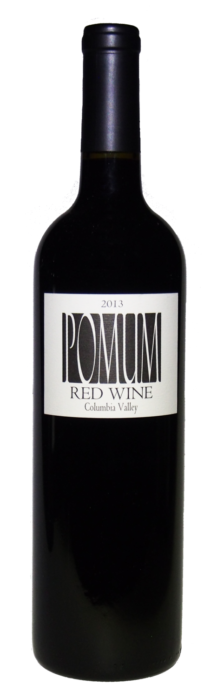
Pomum Cellars nurtures from soil to stem a true expression of American made wine grown in the unique viticultural areas surrounding the Columbia River in Washington State. We feel that these truly handcrafted wines are something special! We hope you agree.
Vintage:
The 2019 growing season started slow with late snowpack in the vineyard delaying pruning and budbreak. The snow also contributed to higher moisture content in the vineyard soils and thus a natural delay in irrigation as well as slightly more vigorous canopies. The growing season was, for one key exception, uneventful which is a good thing in agriculture. Temperatures were overall lower than recent vintages and that always brings a welcomed relief to the vineyard and winery crews. The exception however, a set of hard freezes in mid-October brought down all vine leaves and thus halted any further photosynthesis.

Wine:
Each year Pomum only produces two wines from Bordeaux varieties, our Red Wine and Shya Red. Both of these are now Estate Wines exclusively sourced from our own Konnowac Vineyard. Our Red Wine is the “second” wine of the winery and showcases the variety of flavors found at our site. The wine was fermented in small one-ton fermenters and aged in French oak barrels for 20 months.
34% Petit Verdot, 32% Cabernet Sauvignon, 14% Merlot, 10% Cabernet Franc, 10% Malbec.
Technical Details:

PH: 3.57
Titratable Acidity: 6.45 g/l
Alcohol: 14.5% by volume
Production: 551 cases of 750 ml
Maturation: Aged in 225 liter French oak barrels (20% new) for 20 months.

