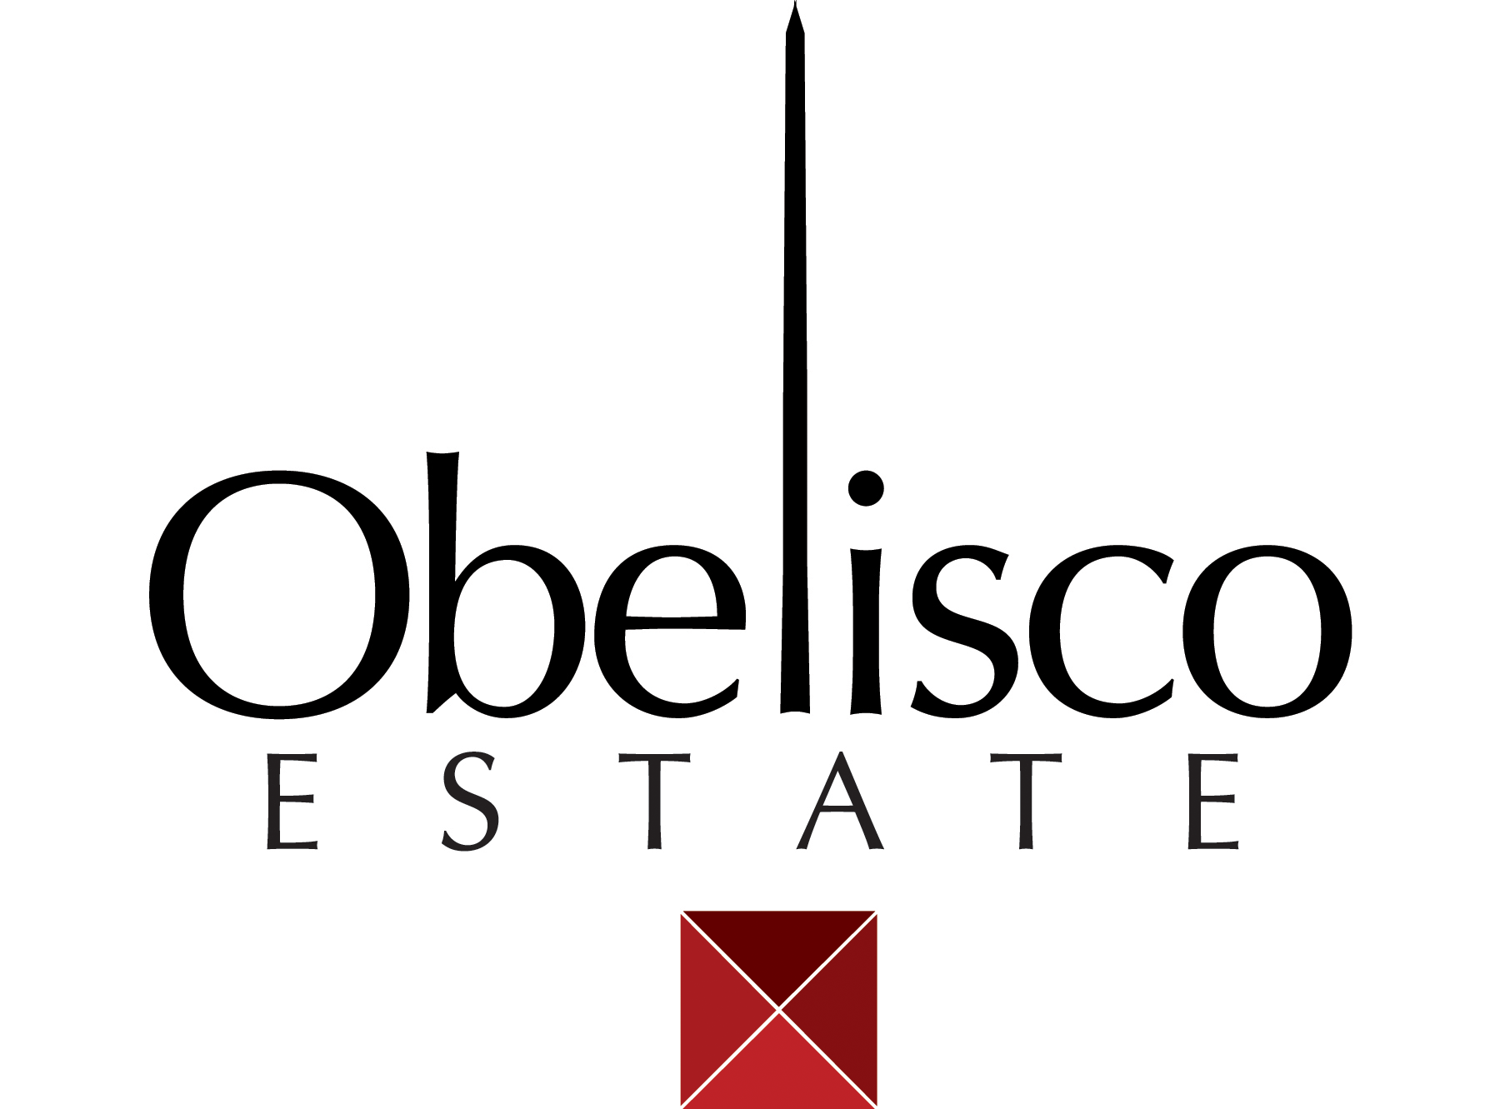

**2014 OBELISCO Cabernet Sauvignon**

**AVA:** Red Mountain

**Winemakers:** Sarah Goedhart, Doug Long

**Blend:** 75% Cabernet Sauvignon, 25% Malbec

**Vineyards:** 100% Obelisco

**Bottling:** 1067 cases 750ml

**Alcohol:** 14.7% vol.

**Barrels:** 30% new French oak, 70% American neutral.

**Tasting Notes:** Dark purple, red color. Dry, yet fruity nose full of dark berries, cherry, blackberries, with accents of spices like basil, and white pepper, followed by slight floral aromas of roses and eucalyptus. On the palate this wine is full, rich and diverse yet dances on the tongue, led by fruit like blackberry, plum, and boysenberry. The fruit tannin blends nicely with notes of Mediterranean spices, clove, basil, cola, and hints of coffee. The mouth feel is full and complicated with flavors changing from front to back with a little bit of zing. Nicely balanced acids and tannins remind you of its’ Red Mt. origins and allows the flavors to linger.

**Cellaring:** Because it is made from Red Mountain grapes this wine should age well for the next 15 to 18 years. Because it is mostly Obelisco fruit it is ready to go at any time.

**Production:** all the fruit for this wine is from Obelisco Vineyard. The high density planting yields smaller berries, which contribute to the concentrated flavors, yet the fruit from this vineyard always makes wines with luxurious tannins and mouth feel. Combine this with 20 months in 30% new oak and you get a wine that invitingly combines great fruit and oak.

**Harvest notes:** 2014 was another excellent, yet hotter weather vintage in Washington State. Yields seemed to be on the average at Obelisco Vineyard close to 3.8T per acre. Harvest was on average sooner than years past.

**www.Obelisco.com **