2022 Cabernet Rose’

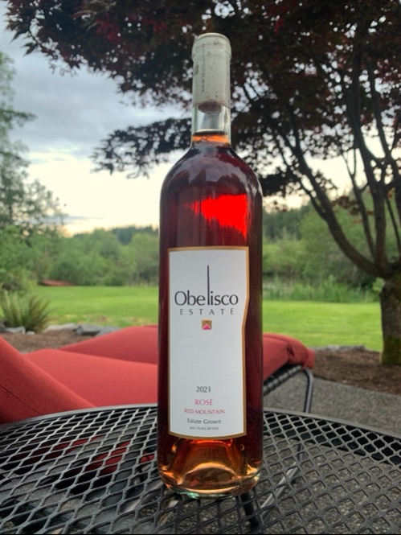
Winemaker: Ken Abbott
AVA: Red Mountain
Blend: 100% Cabernet
Case Production: 185
Alcohol: 13.9% vol.

Fermentation: Stainless Steel
Residual Sugar: .1%
Aging: Stainless Steel

Tasting Notes: Pretty and translucent light strawberry color. It is very rare that Cabernet is picked specifically to make Rose’ but that is what we do here. The Rose’ gets a few days exposed to skins at a very low temperature. The first smell of the wine reveals fresh strawberry, watermelon and a jolly rancher candy-like quality without the sweetness. On the palate, the mouth-feel is full yet dry. The first tasting notes you experience are strawberry with some citrus acid. The center of the palate opens up to more strawberry, tart cherry, watermelon and slight vanilla. The finish carries through with the same fruit and slowly fades to an almost almondy like tail. It is enough to make you smile. The Rose’ flavors you expect are richer and stronger, yet as refreshing as you would want them to be.

Harvest: This fruit is 100% Cabernet and 100% Obelisco specifically picked for our Rose’ It is not the byproduct of any other wine and is never watered down. The 2022 harvest was flavorful and abundant. A lot of terroirs had trouble meeting the sugar levels winemakers want, but Red Mountain always makes it a bit easier. The Cabernet picked specifically for this Rose’ was picked about 2-3 weeks earlier than the normal Cabernet production while the acids were higher with fresh tartness perfect for Rose’. On Red Mountain, the flavors developed in the grapes very early and long before sugar was at the levels most wineries desire. It was an overall cool harvest season which stunted sugar production. We did not feel the stress of a lot of winemakers who wanted to reach certain sugar levels, as we felt the chemistry was great and the flavors were fantastic. It was just going to be a lower alcohol year. The yield was great in 2022 and much better than the previous 2021 harvest which was the lowest yield on record for Red Mountain. Flavors and concentrations shined through and 2022 should be a fantastic year. Red Mt is a step above other AVA’s with more depth and complexity. The minerality and flavors of Red Mountain are definitely unique.

Obelisco @Obelisco Estate www.obelisco.com

