2022 Obelisco White Wine

Winemakers: Ken Abbott
AVA: Columbia Valley
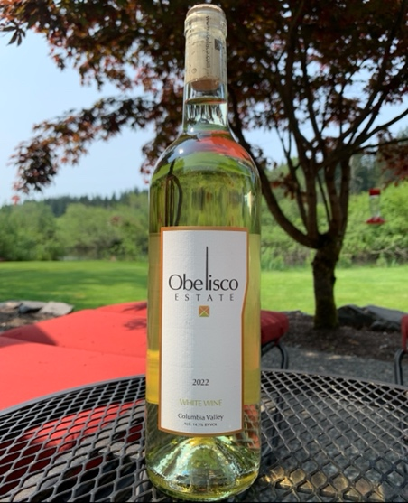
Blend: 65% Sauvignon Blanc, 35% Semillon
Case Production: 208
Alcohol: 14.5% vol.

Fermentation: Stainless Steel
Residual Sugar: .1%
Aging: Stainless Steel for the Semillon. The Sauvignon Blanc aged in French oak. 50% new, 50% neutral.

Tasting Notes: There is a translucent champagne color that is clear and light. The nose comes through with citrus zest, kiwi and a light vanilla along with crisp apple and light melon. The front of the palate starts with tart citrus, starfruit and lychee, then fades to ripe apple with some earthy and melon tones on the back of the palate. Unlike most white wines, the finish sticks around for a long while. The Sauv Blanc saw some oak, so there is some structure to the mouthfeel while the freshness of the Semillon rounds out the full palate experience and adds structure of its’ own. Would be delicious with aged hard goat cheese and other hard cheeses like Parmesan, Reggiano. Perfect with blackened fish, chicken, clams, salads and would pair with sweet desserts easily.

Harvest: The Sauvignon Blanc comes from the Sagemoor Group Gamache Vineyard and the Semillon comes from the Dionysus Vineyard. Both of the locations warrant much longer hang time because the weather is much cooler than Red Mountain. While Red Mountain is perfect for Bordeaux reds, we would not want to plant these white vines on Red Mountain because they would ripen too quickly building sugars, but not flavors. We chose to go off of Red Mountain for these white grapes to places where the grapes take a lot longer to ripen. Often these grapes are harvested after the Cabernet on Red Mountain. That is later in the season than most whites. The Sauvignon Blanc develops great stereotypical flavors while the viscosity of the Semillon improves the mouth feel and forces flavor to linger a bit longer. The 2022 harvest was a plentiful and flavorful harvest. The white grapes were ready early and had lots of flavor while the reds developed lots of flavor, but struggled to finish with sugar production. It was nice to see good yield after two years of very small yield in the fields.

Obelisco @Obelisco Estate www.obelisco.com

