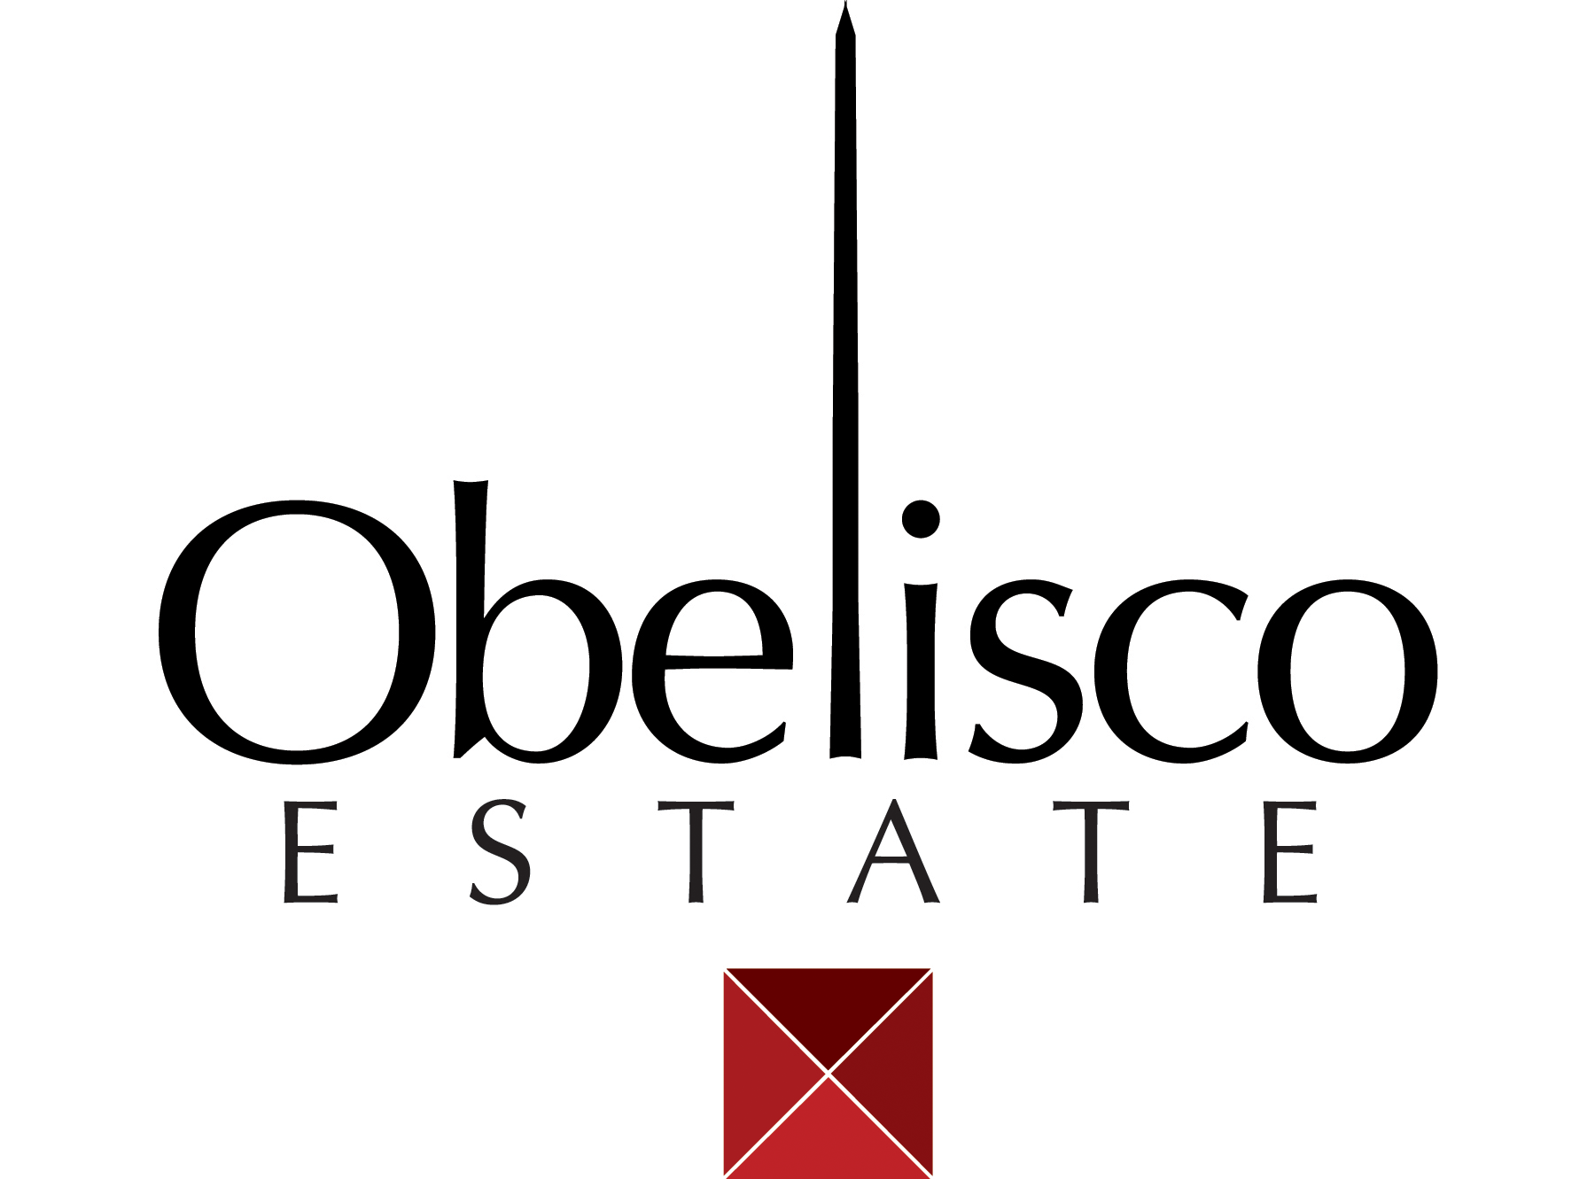

**2019 OBELISCO Syrah**

**AVA:** Red Mountain

**Winemakers:** Ken Abbott, Hope Nastri

**Blend:** 87% Syrah, 9% Cabernet, 4% Malbec

**Vineyards:** Red Heaven, Obelisco

**Bottling:** 275 cases 750ml

**Alcohol:** 15.3% vol.

**Barrels:** 30% new; 100% French

**Tasting Notes:** Deep, dark purple color. On the nose, there is blackberry aroma with dried basil, soft spice, vanilla, and a bit of cocoa. On the palate this wine is full, lush and silky with blackberry fruit, rounded spices, toasted oak and hints of graham cracker and wild berry. It is surprisingly soft, but the flavor presence wakes up the taste buds. The mouth feel is lush and smooth on the entry, dances on your tongue with some subtle acids and then leaves a long tail of rich fruit and spice.

**Cellaring:** Because it is made from quality Red Mountain and Obelisco grapes this wine should age well for the next 5 to 10 years easily. Should get silkier with age.

**Production:** The fruit for this wine is from Red Heaven on Red Mountain and is the Sara Lee clone. Traditionally, this clone is a more fruit forward Syrah, but can also be a fruit bomb. We were careful to bring out the fruit without making it too big. The Cabernet and Malbec added came from the Obelisco vineyard. We added just enough to soften the fruit and enhance its’ characteristics to make it an Obelisco style wine.

**Harvest notes:** 2019 was another hot year in the vineyard, but the early set of the vines led to an easy and good yield. Rather than worrying about yield like some years, we actually, trimmed back some of the fruit on the vineyard to make sure concentrations were good. The sugars and flavors seemed to develop at an even rate making the picking decisions easier for our team. There was enough coolness in the evenings of the Fall to give us some extra hang time without the chemistry changing too much. We were also able to avoid some of the smoke that some got from the wildfires that had been so rampant that time of the year.

**www.Obelisco.com **