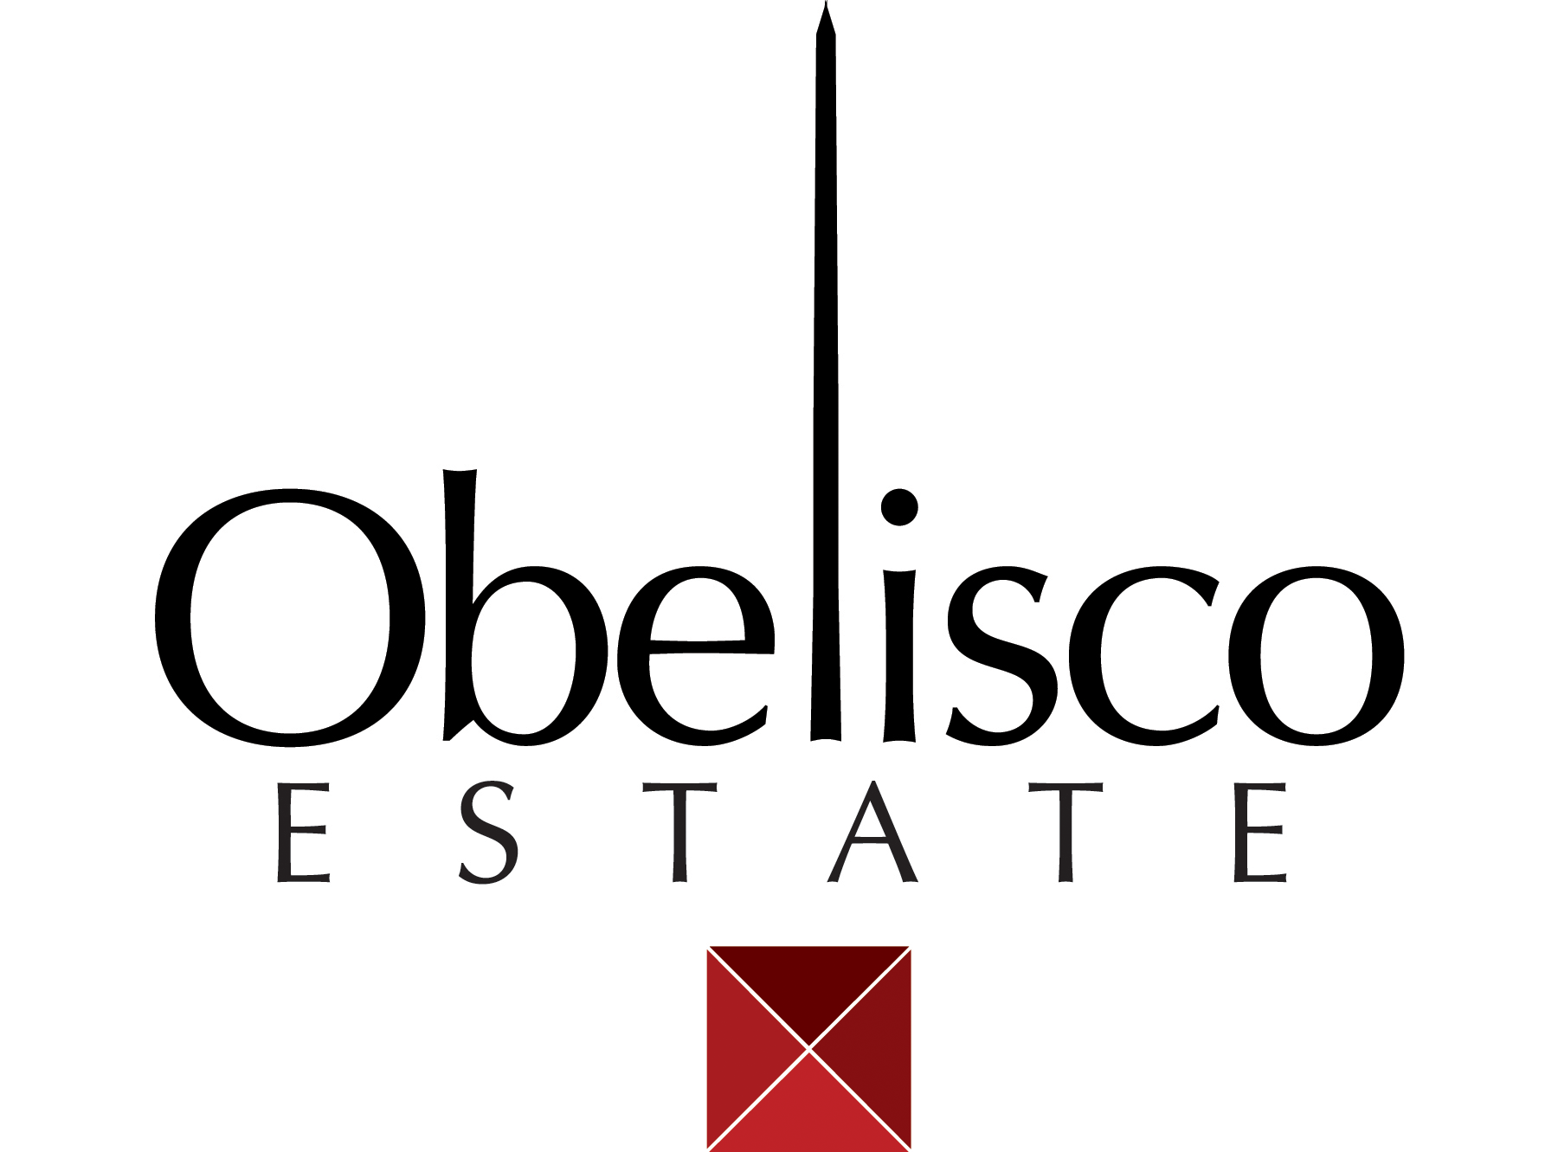

**2013 OBELISCO Cabernet Sauvignon**

**AVA:** Red Mountain

**Winemakers:** Sarah Goedhart, Pete Hedges, Doug Long

**Blend:** 75.4% Cabernet Sauvignon, 5.4% Merlot, 19.2% Malbec

**Vineyards:** 100% Obelisco

**Bottling:** 1214 cases 750ml

**Alcohol:** 14.5% vol.

**Barrels:** 40% new oak; approximately 50% American, 50% French

**Tasting Notes:** Dark purple, red color. Sweet and spicy graham cracker, mincemeat, black cherry and black berry aromas with wet earth, vanilla and butterscotch pudding notes. On the palate this wine is full, rich and slightly sweet with blackberry fruit, mincemeat spice, toasted oak and hints of graham cracker, clove and vanilla. The mouth feel is lush and smooth on the entry, big and juicy on the mid-palate and finishes long with perfect balance of acid and tannins.

**Cellaring:** Because it is made from Red Mountain grapes this wine should age well for the next 15 to 20 years. Because it is mostly Obelisco fruit it is soft and inviting now.

**Production:** all the fruit for this wine is from Obelisco Vineyard. The high density planting yields smaller berries, which contribute to the concentrated flavors, yet the fruit from this vineyard always makes wines with luxurious tannins and mouth feel. Combine this with 19 months in 20% new oak and you get a wine that invitingly combines great fruit and oak.

**Harvest notes:** 2013 was another excellent and more normal vintage in Washington State, although much warmer, which was a welcome change after the cooler and wetter 2010 and 2011 vintages..

**www.Obelisco.com **