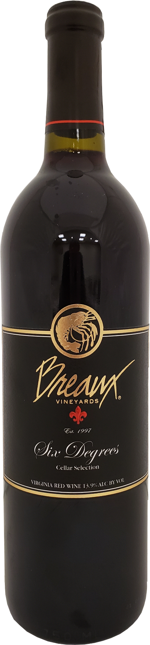
2022 Jolie Blond
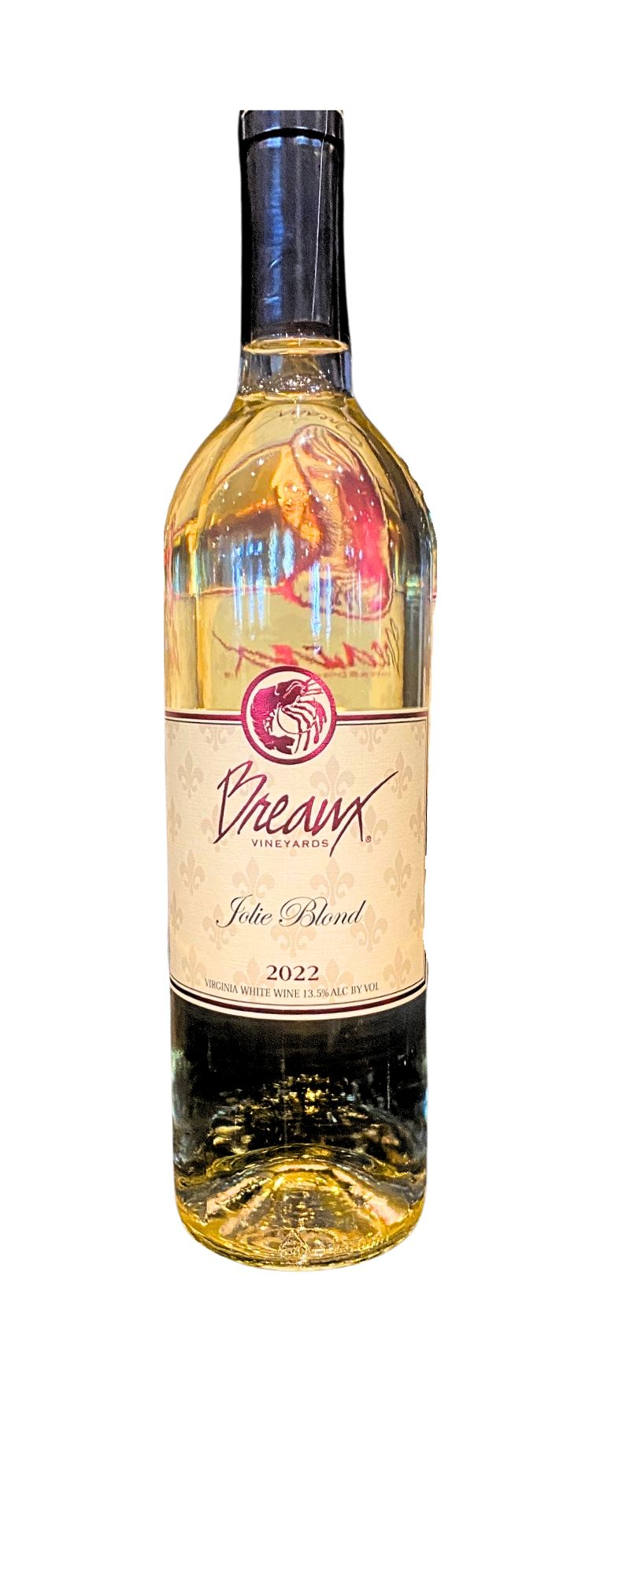

Wine Name – Jolie Blond
Vintage - 2022
Appellation - Virginia
Cases Produced – 143
Blend – 100% Seyval Blanc
Alcohol – 13.5%
pH – 3.53
Total Acidity – 6.4
Residual Sugar – 0%
Harvest Date – Date or dates grapes were harvested
Aging –
Bottling Date – 2/28/23
Tasting Notes – Tropical fruit and bright citrus are coupled with crisp green apple on the nose and palate.
Release Date – 2/18/2024 to Club

