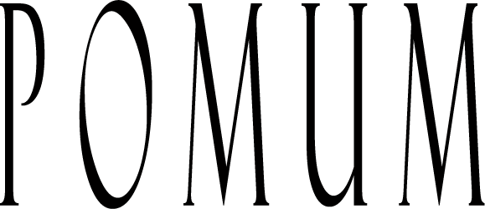

2016 RIESLING
Upland Vineyard

Winery:
Pomum Cellars nurtures from soil to stemware a true expression of American made wine grown in the unique and outstanding viticultural areas surrounding the majestic Columbia River in Washington State. Pomum wines are produced in extremely limited quantities due to our careful attention to detail and focus on quality. We feel that these truly handcrafted wines are something special! We hope you agree.

Vineyards:
Washington State is one of the few places on Earth that excels at growing the classiest white grape of all: Riesling. This fact has been well known in the State for decades and as a consequence some of the earliest vinifera plantings happen to be Riesling.
In 2016 we continue to work with the magnificent Upland Vineyard, one of the oldest Riesling plantings in the State, and located in the recently approved Snipes Mountain AVA. The uniqueness of the vineyard location within the Yakima Valley always guarantees an exciting, terroir driven wine.

Wine:
The wine is made with the utmost respect for the fruit. Our goal is to best convey the vines’ complex story without any obstructions. This means no oak and minimum fining or cold stabilization was used during winemaking. The wine exhibits aromas of citrus, apricot, pear and ginger followed by noticeable minerality and a long finish that is perfectly balanced by the excellent acidity. This wine is ready to enjoy on release and may even evolve further in the bottle for the couple of years.

Blend Composition:
100% Snipes Mountain AVA
100% Upland Vineyard Riesling
Technical Details:
PH: 3.23
Titratable Acidity: 6.2 g/l
Alcohol: 12.5% by volume
Residual Sugar: <0.2% (<2 g/l)
Production: 160 cases of 750 ml
Maturation: Fermented and matured in stainless steel for 5 months.

