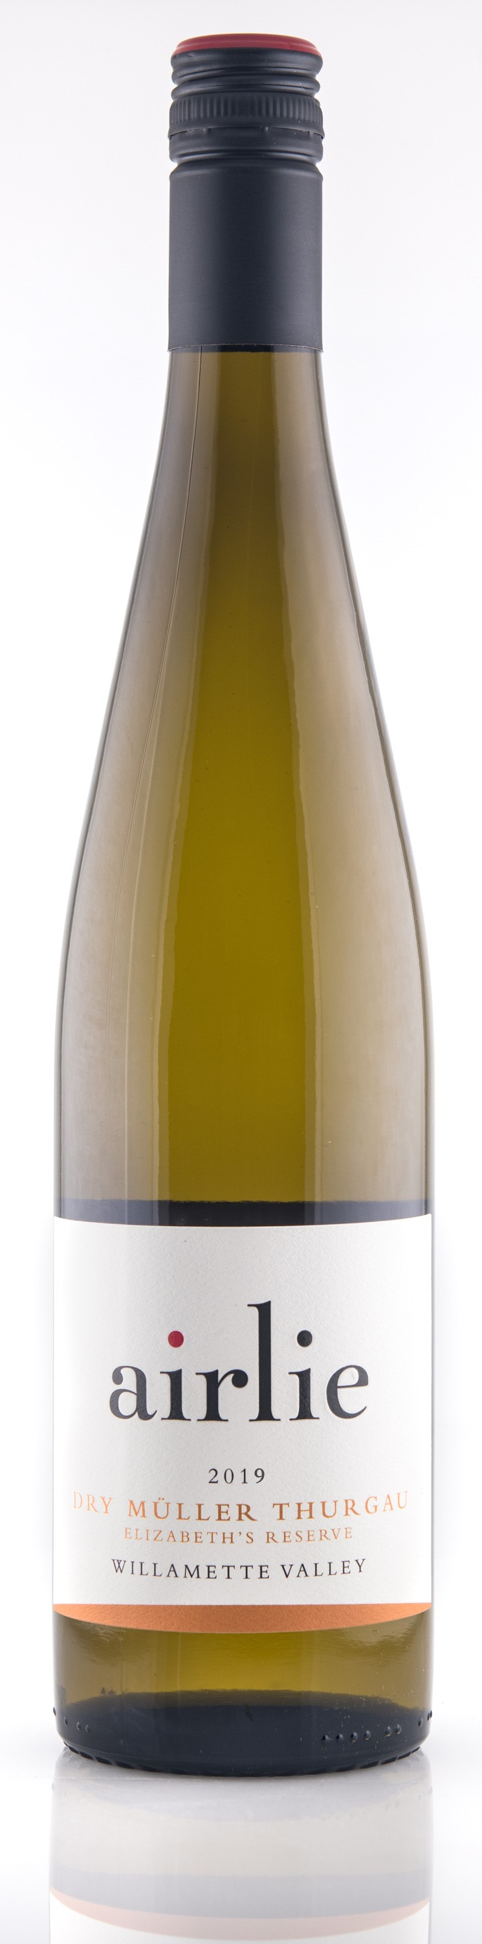
2019 Dry müller thurgau
elizabeth’s Reserve

Tasting Notes:
Aromas of lime zest, pineapple and honeysuckle explode out of the glass in our second iteration of dry Müller Thurgau. This crisp and fruity Riesling cross is loaded with flavors of green apple, pear and orange blossom and the delicate acidity leaves the palate asking for more. Nearly dry, this wine was a goal of Winemaker Elizabeth Clark; create a Müller Thurgau that would make dry white wine drinkers sit up and take notice of this oft overlooked varietal.

Winemaking Notes:
The fruit was gently de-stemmed directly into the press to minimize skin contact. Pressing decisions are done by taste and the press was stopped at just over one bar of pressure. After six days of settling the juice was racked off its lees and a small portion was set aside for this wine. After inoculating with a different yeast than our Estate Müller Thurgau, fermentation temperatures were kept at 55° to 58°F. We stopped fermentation after about three weeks when the acidity and floral notes balanced the touch of remaining sugar. The wine was cold stabilized, crossflow filtered and bottled under screwcap in January 2020.

Harvest Notes:
The 2019 growing season started early with a mild spring and lead into a pleasant but not overly warm summer. Almost reminiscent of what we longtimers like to consider a ‘traditional’ Oregon harvest. We dodged some rain periods during harvest but most rain was followed by a dry period allowing us to let the fruit hang and pick mostly when we would like. Our harvest started on September 25th with the Maréchal Foch and finished October 10th.

Our winery and our estate vineyard, Dunn Forest, are LIVE certified sustainable and Salmon Safe. The vineyard is hand cultivated allowing us to respond to individual vine needs.

Wine Information:  Alcohol: 12%  pH: 3.13  Titratable Acidity: 6.3 g/L  Residual Sugar: 0.45%  Malolactic: No  Aging: Stainless Steel  Number of Cases: 77 | Harvest Information:  Appellation: Willamette Valley  Vineyard Source: Dunn Forest (Estate) planted 1983  Harvest Date: Oct 2nd  Sugar: 19.6° Brix  pH: 3.26  Titratable Acidity: 6.4 g/L

